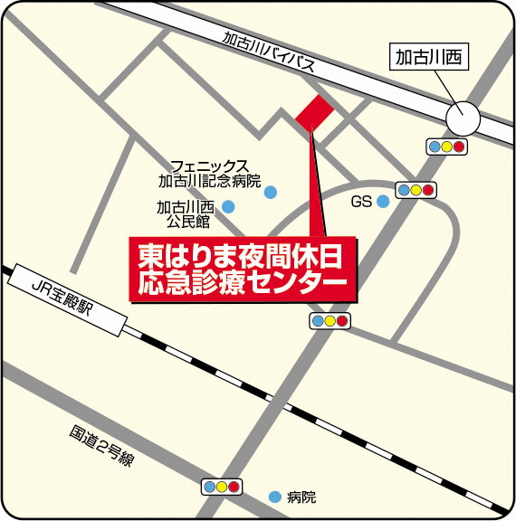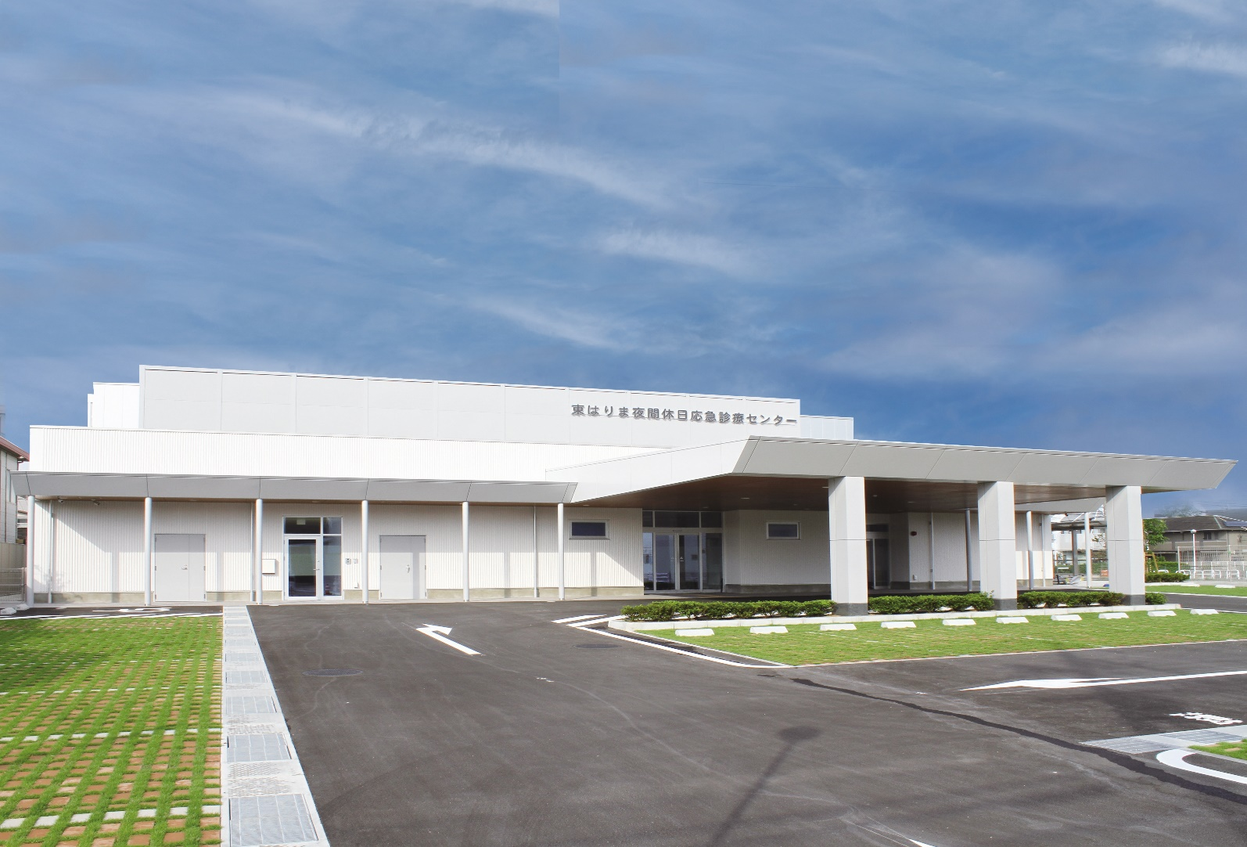

Kakogawa Night Emergency Medical Center has provided night time emergency medical care for internal medicine and pediatrics. From November 1st, 2021 the "Kakogawa Night Emergency Medical Center" will be relocated and the name will be changed to "Higashi Harima After Hours Emergency Medical Center". At this medical center, patients will be able to receive after hours emergency medical care for internal medicine and pediatrics. Night time care for internal medicine and pediatrics is available 365 days a year. In addition, on Sundays, national holidays and year-end holiday, day time care (9:00 am to 6:00 pm) will be available for internal medicine and pediatrics for patients with mild symptoms that are not severe enough to be hospitalized.

* Surgical treatment on Sundays, national holidays and year-end holiday will continue being provided by the on-duty doctors on rotating basis even after November 1st.

**Open on November 1st, 2021.**

**Areas of specialization**:

Internal medicine, Pediatrics

**Consultation hours**:

(Holidays) Sundays, public holidays, year-end and New Year holidays: 9:00 am to 6:00 pm

(Night) Open seven days a week, year-round:

9:00 pm to 6:00 am (Pediatrics until midnight)

**Name**:

Higashi Harima After Hours Emergency Medical Center

**Address**:

379 Nishiinokuchi, Higashikanki-cho, Kakogawa-shi

**Inquiries**:

Kakogawa City Hall, Health and Medical

Department, Regional Medical Division,

**TEL 079-427-9100**

**Higashi Harima After Hours Emergency Medical Center**

**----------------------Priviously called “Kakogawa Night Emergency Medical Center”**